

USS Lafayette Association

Memorandum

|  |
| --- |
| **From Your Reunion Organizers** |



**USS LAFAYETTE REUNION 2022**

PLEASE pay your dues now, so we can calculate reunion costs.

The Association annual dues are $10.00, collected in two year increments of $20. Please pay by check, made out to USS Lafayette Association, and mailed to the Treasurer at Juan Castillo, 1373 East Academy Avenue, Tulare, Ca 93274. If you have questions you may email Juan Castillo at [Juancjcastle@yahoo.com](mailto:Juancjcastle@yahoo.com)

When: September 12th through the 16th.

Where: The Ashworth Hotel, [295 Ocean Boulevard,  
Hampton Beach, New Hampshire](https://www.ashworthhotel.com/tracking/click-location-map.aspx)

Why Hampton Beach: Eight years ago, when we were considering having a reunion at Portsmouth, NH, hotel rates were much more reasonable. As part of The Base Realignment and Closure Act, Pease Air Force Base was closed, and turned over to the City of Portsmouth to become Pease International Tradeport. Many big businesses from around the country relocated to the Tradeport, and the demand for overnight accommodations for visiting businessmen has allowed the downtown hotels in Portsmouth to charge over $350/night, year-around. Dennis Lauze was able to get us a reduced rate of $159/night at the Ashworth Hotel for 4 nights, Sep 12th to Sep 15th. The reduced rate will not be available outside of those dates. The Ashworth is nicely set up to handle reunions. Hampton Beach is 15 miles south of Portsmouth and 22 miles from the Kittery Navy Yard, so an easy drive to tour these locations.

How to get to Hampton Beach: Unfortunately, there is no public or airport transportation to Hampton Beach. So everyone will probably want to rent a car if flying to the area. Portsmouth International Airport at the Tradeport is the only local airport and only serviced by Allegiant Airlines. Allegiant connects to Nashville (BNA), Myrtle Beach (MYR), Punta Gorda (PGD), St. Petersburg (PIE) and Daytona Beach (SFB). Hampton Beach is 16 miles from the Tradeport.

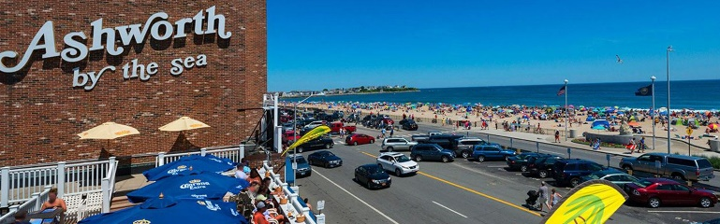Most of you will have to fly to Portland International Jetport in Portland, ME, Manchester-Boston Regional Airport in Manchester, New Hampshire, or Boston Logan International Airport. All three are 50-60 miles from Hampton Beach.

**The view from Sandbar Rooftop Outdoor Bar**

Accommodations and Amenities: Our accommodations are king and double-queen rooms, both at a reduced rate of $159/night. Reservations may be made at the hotel website, <https://www.ashworthhotel.com>. Use promo code USS22 to get our reduced room rate. One unfortunate expense we were not able to get around is you have to use the valet service for parking on premise at $25/night. Free parking may be found on the surrounding streets. Amenities include:

* Indoor Heated Pool
* High-Speed Wireless Internet
* Valet Parking
* 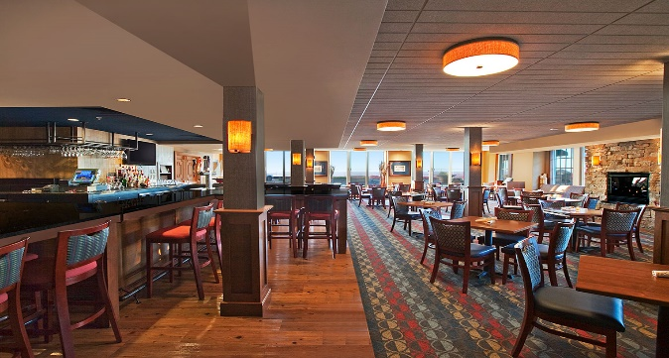Wharfside Café

**Breakers Restaurant and Lounge**

* Breakers Restaurant and Lounge
* Sandbar Rooftop Outdoor Bar
* Fitness Room-Open 8AM-10PM
* 24-Hour Sundries Market
* Flat Screen TVs with Premium Channels
* 24-Hour Business Center
* Over 6,000 Sq. Ft. of Event Space
* Large Sun Deck Overlooking the Atlantic Ocean

Activities: The Portsmouth and Hampton areas are very popular tourist areas, with many things to see and do. We are making arrangements for a tour bus to The USS Constitution Museum in Boston on Tuesday the 13th. We are planning to do “Navy Day” on Wednesday, the 14th. The plan is to drive our personal vehicles to the USS Albacore Park in Portsmouth. After touring the USS Albacore, a tour bus will take us from Albacore Park to the Kittery Navy Yard and museum, past the USS Thresher Memorial and back to Albacore Park, where we will pick our vehicles. Those interested, can make a short drive to the well-known Kittery Trading Post and Kittery Outlets to “shop till you drop”.

We plan to meet the morning after check-in, the 13th, to plan other destinations and make any necessary reservations. If we find destinations that require earlier reservations, we’ll pass that along in a future newsletter. Other activities we can do as a group or individually are:

* A half-day in Portsmouth. Parking at the Hanover Garage, you will be in the center of 4 blocks of the touristy area with many quaint shops and fine restaurants. You may even run into a few buskers.
* Portsmouth was settled in 1623 as Strawbery Banke. Visit the Strawbery Banke Museum, where costumed staff demonstrate traditional crafts in 17th &18th century homes.
* Prescott Park is across the street from the Strawbery Banke Museum, where there are beautiful gardens and usually live entertainment every night.
* There are 3 recommended ways to tour Boston. You can walk a portion of the Heritage Trail for free. Take a double-decker English style bus on the full Heritage Trail that stops at “Old Ironsides”. You can get off the bus at any attraction, and catch one of the next buses to continue your tour. Lastly is the Duck Tour, an amphibious boat tour that takes you to famous points of interest around town and ends in the Charleston River just long enough for you to get wet.
* There are several world-famous museums in Boston and Cambridge, which is on the other side of the Charles River.
* Visit American Independence Museum in Exeter, NH, Capital of the American Revolution.
* Visit several forts in the Portsmouth- Kittery area.
* There are Portsmouth harbor boat and fishing tours and a boat tour to Isles of Shoals, the first settlement in the area, where you can visit the Marine Museum and learn about the Smuttynose Murders, one of the most grisly murders on record.
* There are hundreds of hiking trails in the area sponsored by local land trusts.
* There are several public golf courses in the area.
* Visit the Salmon Falls Pottery Outlet in Dover, NH.
* Red Sox play Kansas City Royals at Fenway Park Sep 16,17,18. Buy tickets soon.
* Visit the McAuliffe-Shepard Discovery Center in Concord, NH, honoring Christa McAuliffe and Alan Shepard.
* The last day of the Hampton Beach Seafood Festival will be on Sep 11th.

Please make note of any of the above activities you are interested in, and we’ll put groups together at the meeting the morning after check-in.

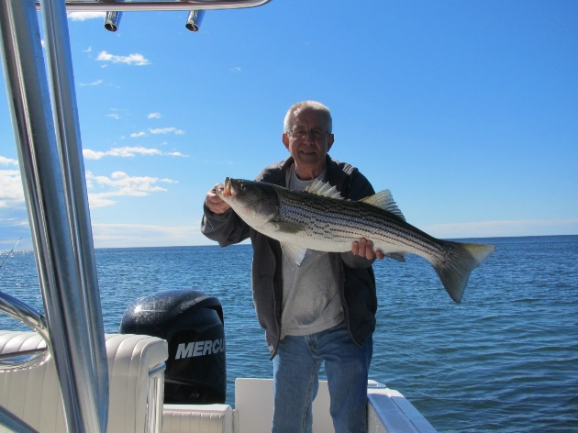About the weather: I’ve heard that a few shipmates have expressed a concern about September in New England being too cold for a reunion. Not to worry! The New Hampshire Seacoast is tempered by the ocean with the gulf stream not too far off shore. September is one of our prettiest months. Daytime temperatures will be in the 70s with low humidity. Ocean temperatures will be near 60 degrees, so the “stripers” (striped bass) will still be around. I can arrange for a half-day fishing trip for $500, guaranteed to catch a 30+” striper.

**Who is that with a 33" striper caught off Kittery Point?**

The schedule of the Tolling of the Bells Ceremony, Business Meeting, Banquet with menu and cost will be posted soon.

Hope to see all of you there!

Dennis and Tim